No. | Scientific names | Local  names | English or Indonesian names | Parts  Used | Uses | Wild/Cultivated
1 | Alpinia malaccensis (Burm.f.) Roscoe | Pasisingin | Malacca galangal | Stem | Childbirth cramps, cuts and wounds, diarrhoea | Wild
2 | Amomum mentawaiense A.J.Droop | Gojot leleu | - | Stem | Cough | Wild
3 | Boesenbergia angustifolia (Hallier f.) Schltr. | Egleu | Chinese ginger | Leaf, whole plant | Hypertension, headache | Wild
4 | Curcuma longa L. | Kiniu | Turmeric | Rhizome, Leaf | Stomach ache | Cultivated
5 | Curcuma zanthorrhiza Roxb. | Kiniu-ra'ba' | Temu lawak | Rhizome | diarrhoea, back pain, Childbirth cramps, bruises and sores, dye body. | Cultivated
6 | Elettaria longituba (Ridl.) Holttum | Alutuet | - | Flower, Leaf, Stem | Headache, stomach ache, back pain, allergies to insect bites | Wild
7 | Etlingera coccinea (Blume) S.Sakai & Nagam. | Pelekak | - | Flower | Addition on medicinal herbs | Wild
8 | Etlingera elatior (Jack) R.M.Sm. | Totonan | Rose torch lily | Rhizome | Headache, vomiting, eye infections, breast swelling | Wild/Cultivated
9 | Etlingera elatior var. alba Todam & C.K.Lim | Gojo | White torch lily | Rhizome | headache, vomiting, eye infections, breast swelling | Wild/Cultivated
10 | Etlingera foetens (Blume) R.M.Sm. | Kukuan | - | Stem | Headache | Wild
11 | Etlingera pyramidosphaera (K.Schum.) R.M.Sm. | Sumamaik | Black tulip ginger | Rhizome | Internal injured | Wild/Cultivated
12 | Etlingera littoralis (J.Koenig) Giseke | Pelekak | - | Flower | Addition on medicinal herbs | Wild
13 | Geocharis sp. | Sipubaglao | - | Stem | Boils | Wild
14 | Globba flavibracteata A.Takano & H.Okada | Silukkuk | - | Whole plant | Asthma, Cough | Wild
15 | Globba atrosanguinea Teijsm. & Binn. | Tamalalauk | - | Whole plant | Headache | Wild
16 | Globba unifolia Ridl. | Leigat leleu, Silukuk onaja | - | Whole plant | Asthma | Wild
17 | Globba variabilis Ridl. | Sipu popoirag | - | Whole plant | Asthma | Wild
18 | Globba multifolia A.Takano & H.Okada | Silukkuk | - | Whole plant | Cough | Wild
19 | Globba leucantha Miq. | Sipu popoirag simabulau | - | Whole plant | Asthma | Wild
20 | Hedychium flavescens Carey ex Roscoe | Simakaino silimun Tainao | Cream ginger lily | Leaf, Flower | Stomach ache, back pain, fever | Cultivated
21 | Hedychium coronarium J.Koenig | Tainao simabulan | White ginger lily | Flower, Stem | headache | Cultivated
22 | Hedychium longicornutum Griff. ex Baker | Kinande, siputainaok | Hornbill’s ginger | Rhizome | diarrhoea, Stomach ache, itchiness | Wild
23 | Hornstedtia cf. deliana Valeton | Kara-kara | - | Stem | Fever | Wild
24 | Hornstedtia conica Ridl. | Sikukuet | - | Stem | Childbirth cramps | Wild
25 | Hornstedtia parviflora Ridl. | Kamumulek, Roddot | - | Rhizome | Headache, Cough, poison crab allergy | Wild
26 | Hornstedtia tomentosa (Blume) Bakh.f. | Sailulua | - | Rhizome | Childbirth cramps, back pain | Wild
27 | Horstedtia sp. | tatandak, sibeususi | - | Stem | Vomiting | Wild
28 | Kaempferia galanga L. | Kopuk | Kencur | Rhizome | Stomach ache, fever, rheumatism | Cultivated
29 | Plagiostachys mucida Holttum | sikak-sikak, pasisikak |  | Leaf | Fever, vomiting | Wild
30 | Zingiber officinale Roscoe | Laigak | Ginger | Rhizome | Stomach ache, Childbirth cramps | Cultivated
31 | Zingiber zerumbet (L.) Roscoe ex Sm. | Siguju' | Zerumbet ginger | Rhizome | Stomach ache | Cultivated
32 | Zingiber zerumbet var. littoralis Valeton | Palakokoaik, Laigak saileu | Zerumbet ginger | Rhizome, Leaf | Fever, back pain | Cultivated
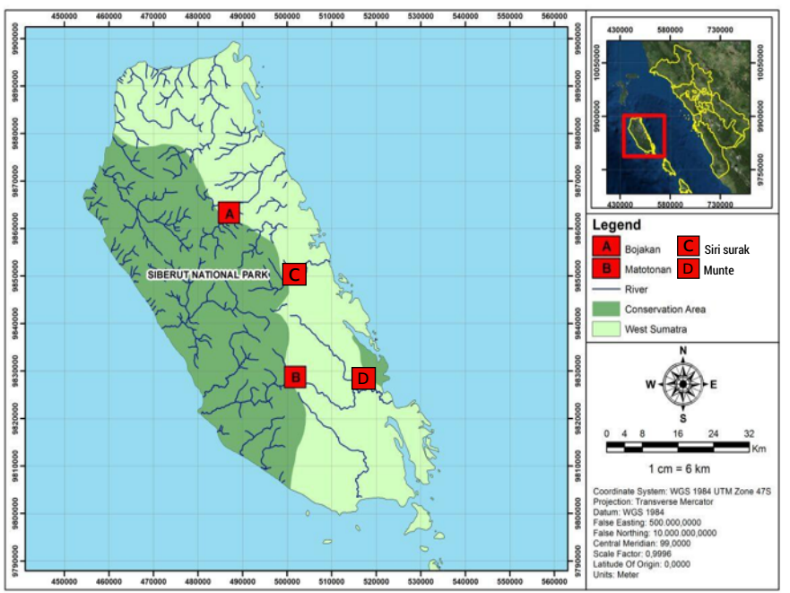
Fig. 1. Map of the study localities on the Siberut Island, Kepulauan Mentawai district (see the legend for details). Inset: the map of West Sumatra province highlighting the position of Siberut island.

Fig. 2: Plant parts used of medicinal Zingiberaceae species by the Mentawai people living in Siberut.

Fig. 3. Number of Zingiberaceae species used for traditional medicine of Mentawai tribe in the Siberut Island.

