Table 1. Socio-Demographic Characteristics
 | Characteristics | Frequency | Percentage
Sex
 | Male | 15 | 50
 | Female | 15 | 50
Age
 | 15-24 yrs | 17 | 56.7
 | 25-34 | 8 | 26.7
 | 35-44 | 3 | 10
 | 45-54 | 2 | 6.7
Education level
 | Elementary School | 2 | 6.7
 | Junior High School | 2 | 6.7
 | Undergraduate | 21 | 70
 | Graduate | 4 | 13.3
 | Doctoral | 1 | 3.3
Occupation
 | Farmer | 2 | 6.7
 | Freelancer | 1 | 3.3
 | House-Wife | 2 | 6.7
 | Lecturer | 1 | 3.3
 | Part-time worker | 1 | 3.3
 | Student | 22 | 73.3
 | Self-Employed | 1 | 3.3

Table2. Perceptions and Attitudes of local communities in regarding with ecotourism and butterflies
Survey Questions | Frequency |  | Percentage
 | Yes | No | Yes | No
Q1. Do you know about ecotourism? | 26 | 4 | 86.7 | 13.3
Q2. Do you know some of the ecotourism places around West Sumatera? | 24 | 6 | 80 | 20
Q6. Do you know the term “biodiversity”? | 28 | 1 | 93.3 | 3.3
Q7. Do you think ecosystem is important in maintaining biodiversity? | 29 | 1 | 96.7 | 3.3
Q8. Do you see butterflies around your environment? | 28 | 2 | 93.3 | 6.7
Q9. Are butterflies beneficial to the environment? | 30 | 0 | 100 | 0
Q14. Have you ever seen these species in your community? | 18 | 12 | 60 | 40
Q21. Do you willing to pay to visit an ecotourism object with butterflies inside? | 24 | 6 | 80 | 20
Q22. If you are going to an ecotourism area, are you interested in seeing butterflies there? | 27 | 3 | 90 | 10

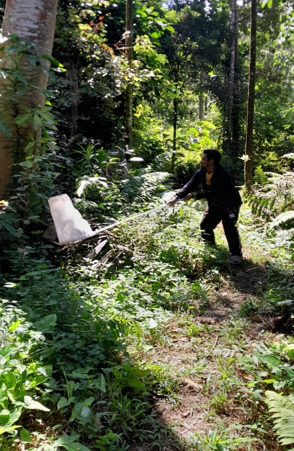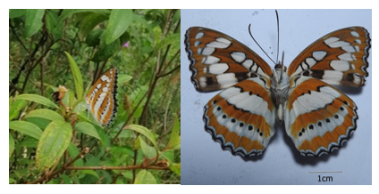
Figure1. (a) Butterfly’s Sampling (b) Butterfly’s picture at one of the Ecotourism areas in West Sumatera

Figure 2. The respondents in West Sumatera

Figure 3. Community perception of the ecotourism development provides a way to increase local’s income

Figure 4. Recorded (a)Butterfly’s activity and (b)Butterfly’s food by respondents

Figure 5. (a). Butterfly’s habitat (b) Butterfly’s attractive character indicated by interviewee

Figure 6. Butterfly’s active time around the respondents’ surroundings

Figure 8. Choice of ecotourism program

